Project Category:

This software will follow Object Oriented Programming Paradigm and use below mentioned areas.

Front End/ GUI Tools: Visual Studio 2010, .NET 4, C#
Backend: MySQL
Networking Technologies: TCP/IP
Wireless Technologies: Bluetooth
Operating Systems: Windows XP, Windows

Tools/Platform, Hardware and Software Specification

Hardware and Software Specification

Hardware Requirement
- Disc capacity : 10 MB of available hard disk space
- RAM : 1 GB (32 Bit) or 2 GB (64 Bit)
- Processor : 1.6GHz or faster

Software Requirement
- Windows XP (x86) with Service Pack 3 / Windows Vista (x86 & x64) with
Service Pack 2 / Windows 7 (x86 & x64)
- Microsoft .NET 4.0

Tools/Platforms used (Hardware/Software):

Hardware Used
- Laptop with 2GHZ processor
- 2 GB RAM
- 320 GB hard disk (NTFS File System)

Software Used
- Windows XP (x86) with Service Pack 3 / Windows Vista (x86) with Service Pack 2 / Windows 7 (x86)
- Microsoft .NET 4.0
- Windows Presentation Framework(WPF)
- Windows Communication Framework(WCF)
- Visual Studio 2010 Express Edition (IDE)
- MySQL Workbench
- Dia for Diagram Drawing & Modeling.

REQUIREMENTS AND ANALYSIS
Construction Management System will provide a cost effective & efficient software solution for managing everything about Construction. Different components of Construction Management System are depicted below.

Problem Definition
Construction Management System is being developed keeping in mind the hectic management and control procedure of a construction site. A contractor not only needs to manage his workers and raw materials, he also needs to plan properly to keep his commitment to his customers. Bringing raw materials, scheduling works and tracking progress would be lot easier using the application Construction Management System.

Scope of the Solution
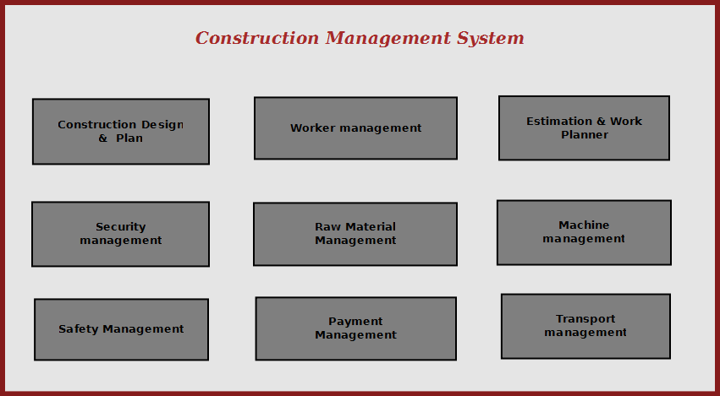

Figure: Scope of Construction Management System

Construction management system will enable the site manager to control all aspects of construction from a standalone solution. It allows managing, searching and referring important data used in construction; it makes site managers life easy to operate construction activities flawlessly.
The main features of this software are given below:
  - Construction design and planning using external designer software
  - Design viewer and add comments.
  - Worker attendance management.
  - Worker Identity info saving and security management
  - Raw material stock & pricing information query.
  - Estimation & planning of future work.
  - Monthly / daily progress report
  - Supply management & payment tracking.
  - Safety assurance
  - Transport management
  - Legal work management

Analysis

Database & Table Details
Tables | Keys
Worker | User Id, Name, Address , Contact Number, skillset, Photo ID Num, Photo
Construction Management System | Construction site Id , Name, Address, Registered no
Construction Machine | Machine Id, Name, purpose
Work Session | Session Id, worker Id, Time, Expense amount
Engineer | engineer Id, Name, address, contact number
Design Preference | Preference Id, Type, Description
Raw Material | Product id, stock, name, price

Complete Structure

Process Logic
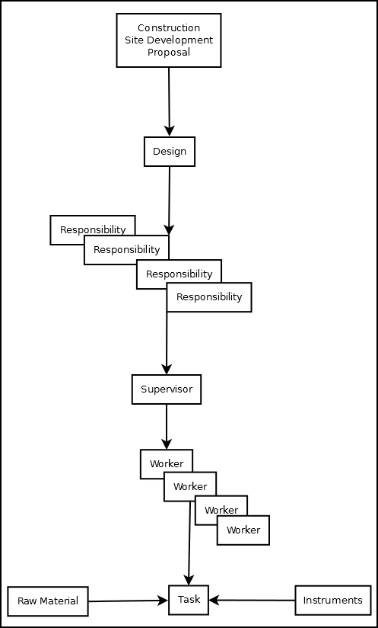

Implementation Methodology
- Object Oriented Programming methodology will be adopted and C# will be used as programming language.
- Apache tomcat web server will be used to implement the server
- User interface development will be done in MVC architecture using WPF (Windows Presentation Framework).
- Relational DBMS MySQL will be used to implement & execute SQL query to database.
- Agile Software Development model will be used while developing this software.

List of Reports

List of reports that are likely to be generated in this software are given below:
- List of Raw materials used/purchased can be generated
- List of Labors/workers can be generated
- List of buyers can be generated
- Work progress details can be generated
- Fund details can be generated

Implementation of Security Mechanism at Various Levels
- It provides users a login interface that requires a password. The password could be changed by admin only.
- There would be multiple user login option, i.e. clerk, officer, admin etc.
- The login password will be saved in encrypted format in database.
- This software will use Google open-id authentication for web interface.

